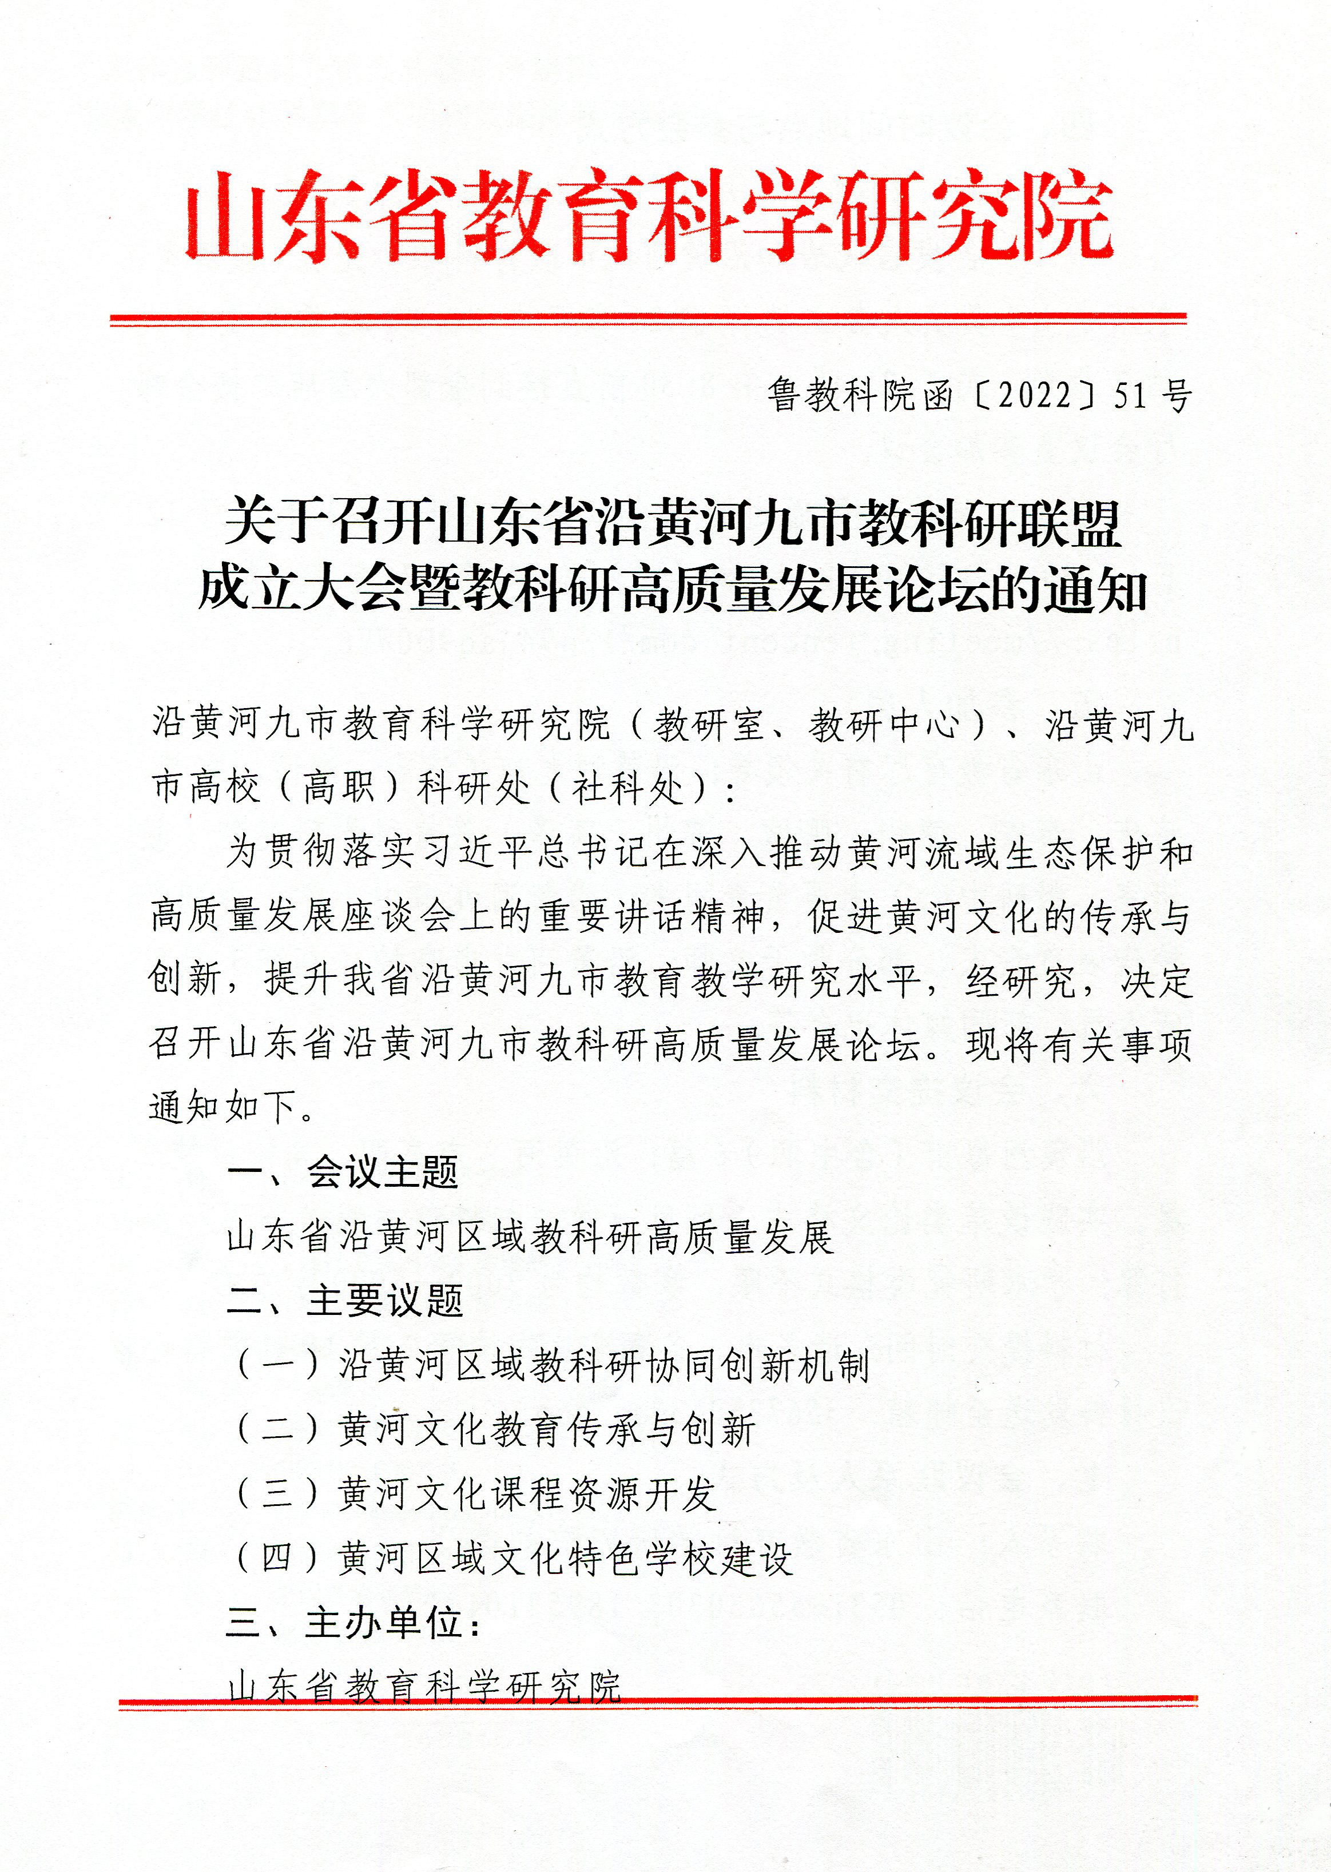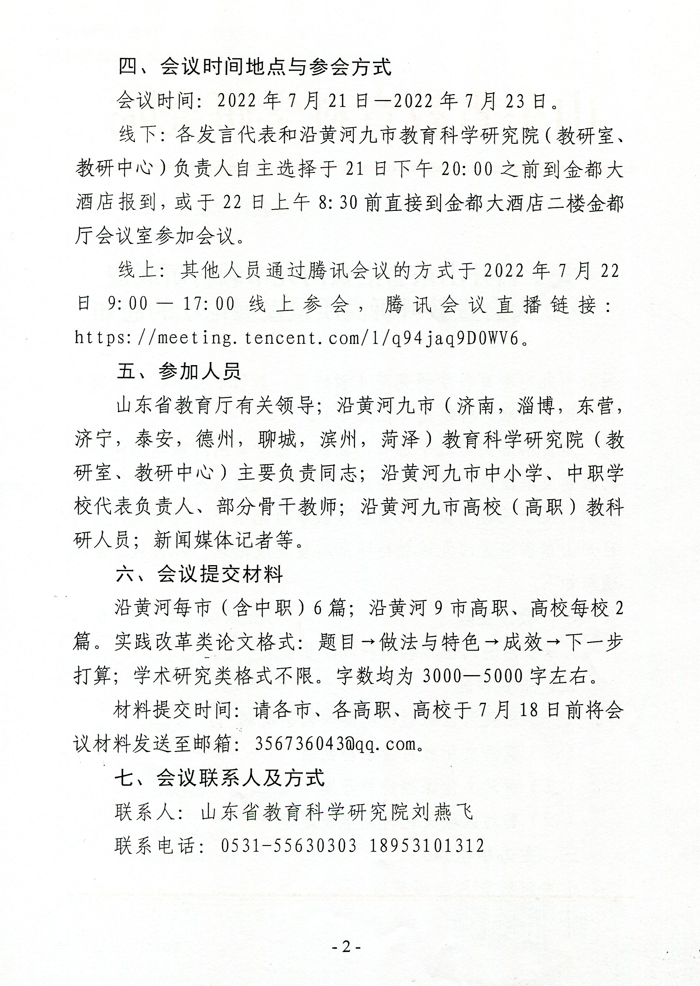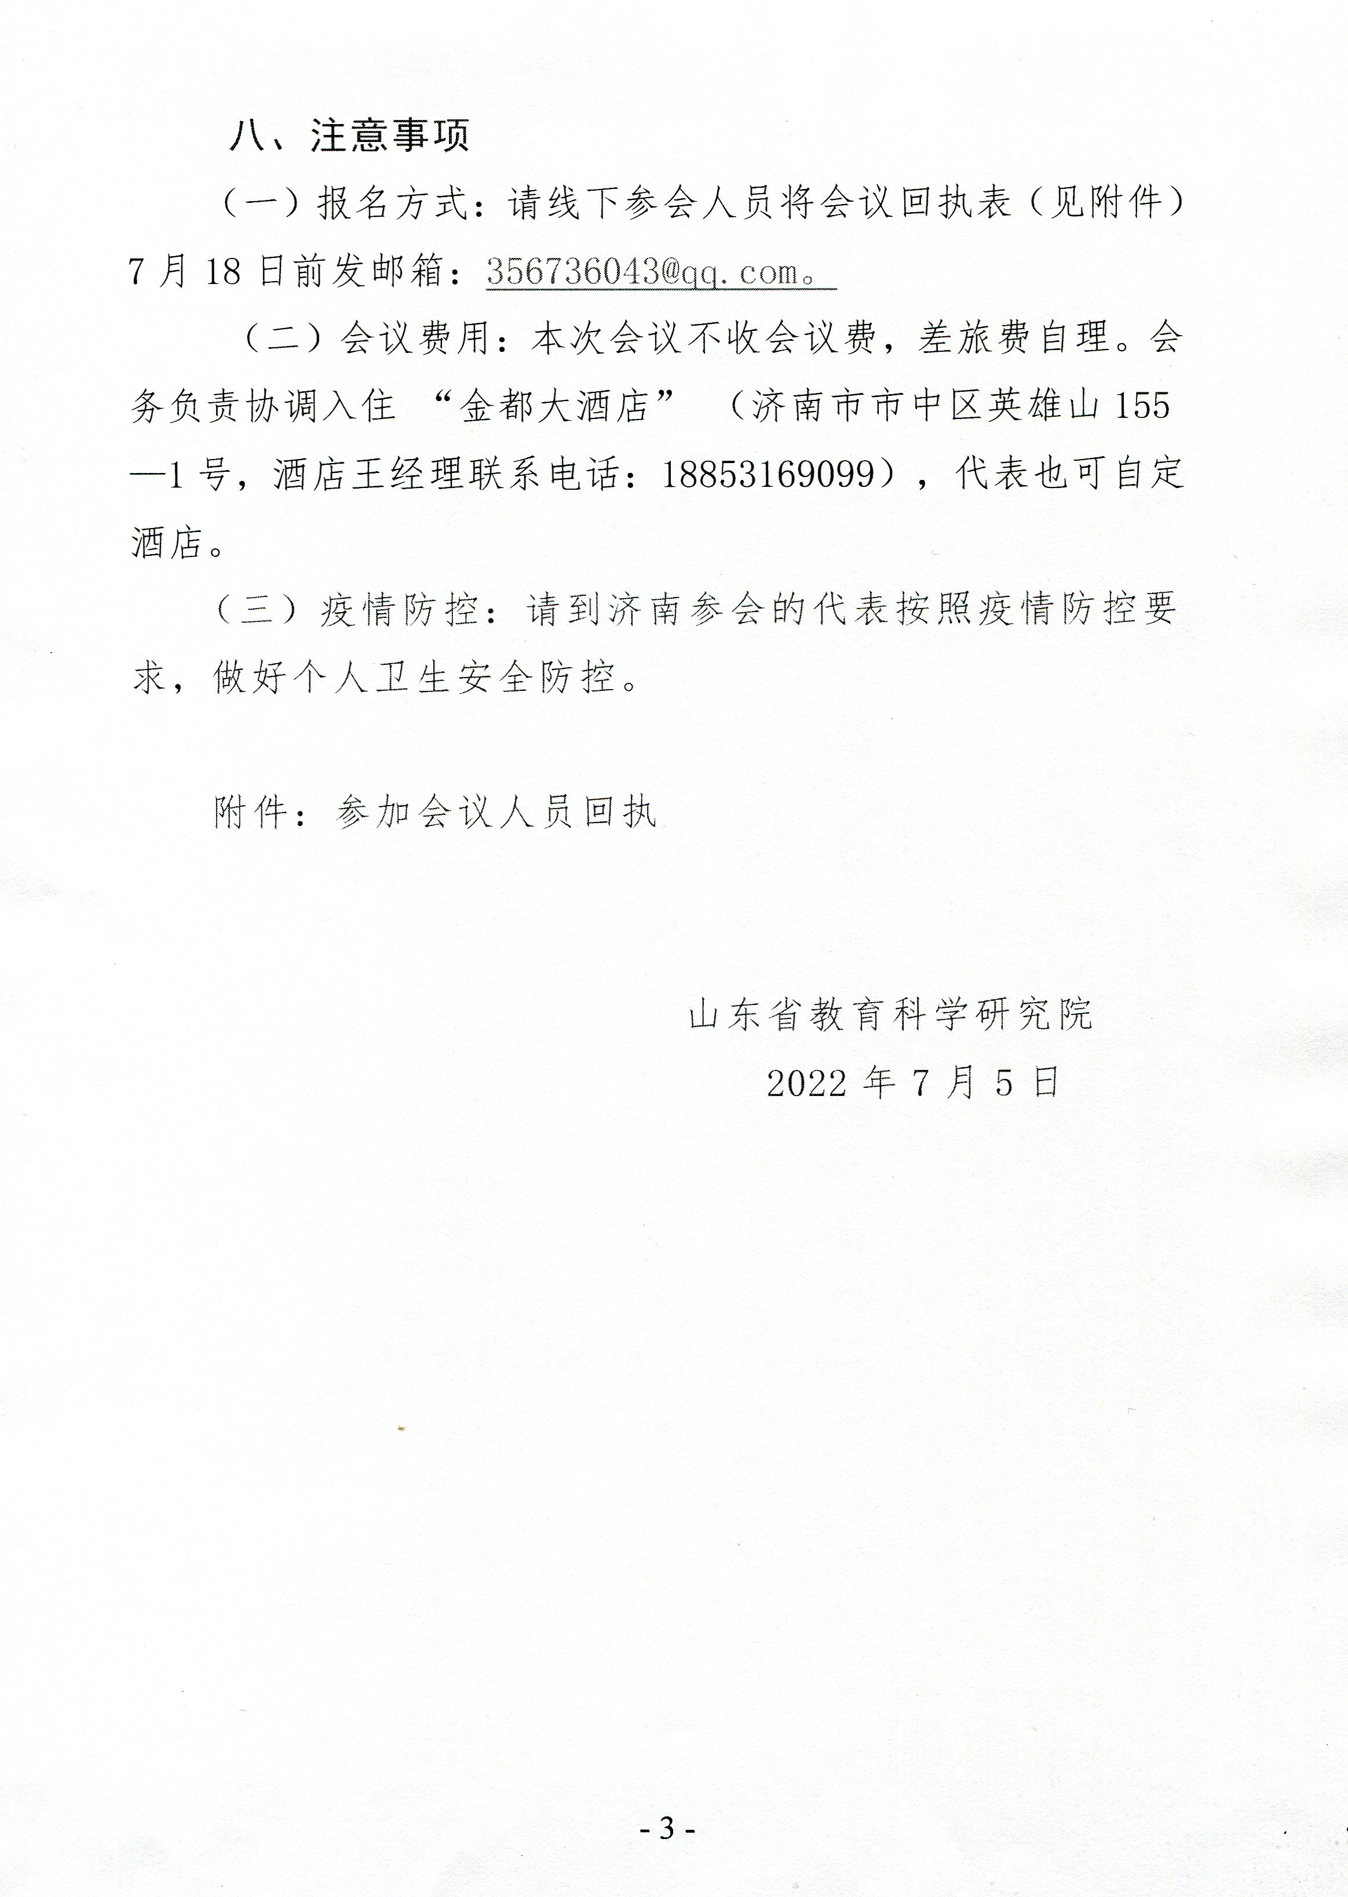

附件

参加会议人员回执

|  |  |  |  |  |  |
| --- | --- | --- | --- | --- | --- |
| 姓名 | 单位 | 职务/职称 | 联系电话 | 住宿要求 | 备注 |
|  |  |  |  |  |  |
|  |  |  |  |  |  |
|  |  |  |  |  |  |
|  |  |  |  |  |  |
|  |  |  |  |  |  |
|  |  |  |  |  |  |

**说明：**线下参会人员请在“住宿要求”一栏中说明是否入住金都大酒店，并请说明入住时间、离

开时间，房间规格（单人间/标间）及其数量等。